**ISMG 4750 Business Intelligence and Financial Modelling- Assignment**

**Prathamesh_Dhapodkar_109171717**

Question 1:

Calculate the contribution per hour for sales to commercial customers at the current price. How much total contribution is generated for the first quarter of the year from commercial customers? Using revenue hours for the month of January as a reference for sales to commercial customers, calculate the difference in total contribution in January that would be generated for the first 2 scenarios outlined in question 5 of the case (first two bullet points of increase price, decrease price). Compare against the reference case of January.

Solution:

**Total contribution for quarter 1: 305434.88**

**Contribution per hour for commercial customers For January: 771.30**

**Contribution per hour for commercial customers For February: 771.30**

**Contribution per hour for commercial customers For March: 771.30**

The Salem Telephone company and the Salem Data Services has two types of sales, they are Intracompany and commercial. The question asks for the quarterly contribution and hourly contribution for the commercial sales. The current rate for the month for commercial customers is 800$. The total revenue is calculated by **Revenue = Rate * Hours.** The variables costs in this scenario is Power and Operations Hourly personnel. These have been taken as the variables costs as they changes according to the number of hours. The total expense for the variable cost is calculated by **Total expense = sum (variable expense).** The Variable cost per hour is calculated by **Variable cost per hour = (total expenses/total hours).**  Once the variable cost per hour is calculated, I have calculate the variable cost for commercial sales by **Variable expense = variable cost * commercial hours.**

The Variable expense is the total expense from the variable costs. This is required to calculate the contribution. Contribution and contribution per hour is calculated by:

**Contribution = Revenue - Variable expense**

**Contribution/hr = contribution/hour**

There are two scenarios to be analyzed:

Scenario 1: Less demand and More Cost: In this scenario the cost is increased to 1000$ and the demand decreases by 30%. The As we know if the cost of a product increases automatically there are chances for the sales also decrease.

**30% less demand = 30% less sale**

Here I have taken the sales to be the revenue hours. According to my calculation the new revenue hours is given by**: new hours = actual hours - (30/100) * actual hours).** With this, the new revenue hour we get is 86.1. The contribution is calculated on the basis the new revenue hours. In this case there is a loss as the contribution decreases to 83629.01 from 94870.01.

Scenario 2: More Demand Less Cost: In this scenario the commercial sales were billed at 600$ per hour which is lesser than the original January Case. Here there is **30% more demand = 30% more sale.**  The new revenue hours is calculated by **new hours = actual hours + (30/100) * actual hours).**  As the price decreased the demand increases by 30% and the revenue hours increases to 159.9. Even then there company incurs as loss as the contribution decreases from 94870.01 to 91351.02.

Therefore, in both these scenarios the strategy adopted by the company to increase revenue cannot be called successful as both the cases incur loss.

Question 2:

What are the strategic implications of the potential price changes? For each scenario, what changes would the company need to make to align itself with each pricing change scenario. Given the questionable future of Salem Data Services and Salem Telephone Company, which pricing decision do you suggest and why? Why is it the best solution for the company?

Solution:

When we see the revenue and company growth, ideally company should perform well with same cost means it should sell more hours to the commercial customers with same cost to generate profit out of given data. Their strategy should be focusing on **planning** to acquire more commercial clients. For this company can adopt a new marketing strategy. They can also come up with specific **ploys** like some extra services from STC which would make SDS more competitive following the condition that the service quality is at its best, retaining old customers and acquiring new customers. It can come up with a new **perspective** to use the services making use of offers. They can continue the new trend of perspective as a **pattern** to attract new customers which would contribute towards the revenue off the company.

**But for the suggested scenarios, if we compare them both, the company should go with the scenario 2 where it reduces the cost and increases the demand which generates less loss to the company.** But in my perspective company **should create a new scenario** which refers to 100 decrease to costs. Where total cost would become $700 for commercial customer hours and demand would increase by 15% which would generate more contribution to the company.

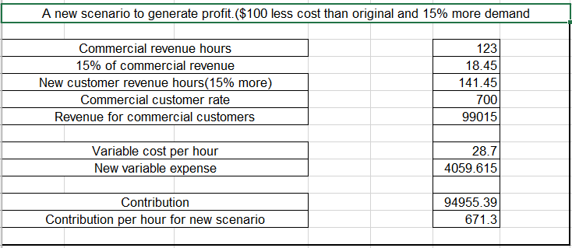

Here profit percentage would be 0.09%. And if company work on its strategies with this new scenario it could generate more profits based on its new sale.

Tables:

